**Experiment No. 01**

**Title: Mini Project**

**Batch: A3 Roll No.: 16010421119**

**Experiment No.:01**

**Aim:** Mini Project on object oriented software engineering for a business application.

**___________________________________________________________________________**

**Resources needed:**

**___________________________________________________________________________**

**Activities:**

**Students are required to choose one business application and prepare following for the same.**

1. Problem Definition
2. Project Scope
3. Choice of Process Model
4. Roles and Responsibilities
5. GUI based Implementation of one Module(one use case)

**___________________________________________________________________________**

**Results:**

**Problem definition:**

The increasing threats to wildlife habitats, biodiversity loss, illegal activities such as

poaching, deforestation, and human-wildlife conflicts pose significant challenges to

conservation efforts, ecological balance, and sustainable development. Traditional monitoring

methods are often inefficient, time-consuming, and costly, limiting the ability to collect real-

time data, identify critical areas, and implement effective interventions. Therefore, there is a

pressing need for an integrated, technology-driven solution that leverages drones, cameras,

sensors, data analytics, and collaboration to enhance wildlife monitoring, conservation

management, research, education, and stakeholder engagement.

**Project Scope:**

The project aims to develop a comprehensive Remote Wildlife Monitoring and Conservation

Application that encompasses:

Aerial surveillance using drones equipped with cameras and sensors for habitat monitoring,

wildlife tracking, and environmental assessment.Installation of camera traps and sensor

networks across strategic locations within protected areas, wildlife corridors, and critical

zones. Data collection, analysis, visualization, and reporting functionalities to support

conservation planning, management interventions, and policy development.

Collaboration and stakeholder engagement initiatives to foster partnerships, knowledge

sharing, capacity building, and community involvement.

Education and outreach programs to raise awareness, promote conservation literacy, and

encourage public participation in wildlife conservation efforts.

**Choice of Process Model:**

For the development of the Remote Wildlife Monitoring and Conservation Application, the

Iterative and Incremental Development Model will be chosen. This model allows for

continuous improvement, feedback loops, flexibility, and adaptability throughout the project

lifecycle. It enables stakeholders to prioritize requirements, address emerging challenges,

integrate new technologies, and refine functionalities based on user feedback, technological

advancements, and conservation priorities. The iterative approach facilitates incremental

delivery, risk mitigation, quality assurance, stakeholder engagement, and alignment with

evolving needs, objectives, and constraints.

**Roles and Responsibilities:**

Project Manager: Overall coordination, planning, execution, monitoring, and control of the

project activities, resources, timelines, budget, and stakeholders.

Technical Lead: Architectural design, technology selection, system integration, development

frameworks, tools, platforms, and technical quality assurance.

Data Scientist: Data collection, preprocessing, analysis, modeling, visualization, insights

generation, predictive analytics, and data-driven decision-making.

GIS Specialist: Spatial data management, mapping, visualization, spatial analysis,

geographic information systems, and environmental planning.

Drone Operators: Aerial surveillance, data capture, image acquisition, video recording,

flight planning, safety protocols, and equipment maintenance.

Field Researchers: Camera trap deployment, sensor network installation, wildlife

monitoring, habitat assessment, data collection, and field observations.

Community Engagement Officer: Stakeholder collaboration, partnership development,

capacity building, training, education, outreach, and communication.

UI/UX Designer: User interface design, user experience optimization, interactive prototypes,

usability testing, accessibility, and visual aesthetics.

Quality Assurance Team: Testing, validation, verification, bug tracking, issue resolution,

performance optimization, and quality control.

**GUI based Implementation of one Module(one use case)**

Module: Aerial Surveillance and Habitat Monitoring

Functionality:

Display live drone footage, images, and sensor readings from selected wildlife habitats,

protected areas, and critical zones.

Enable users to navigate, zoom, pan, and interact with the aerial maps, layers, markers, and

annotations.

Provide access to historical data, trends, patterns, alerts, and notifications related to habitat

changes, wildlife sightings, human activities, and environmental threats.

Allow users to configure settings, filters, parameters, and preferences for data visualization,

analysis, reporting, and sharing options.

By focusing on this module, stakeholders can monitor wildlife habitats, assess environmental

conditions, track endangered species, and identify conservation priorities effectively.

The GUI-based implementation will enhance user engagement, data accessibility,

visualization capabilities, and decision-making support for conservation initiatives.

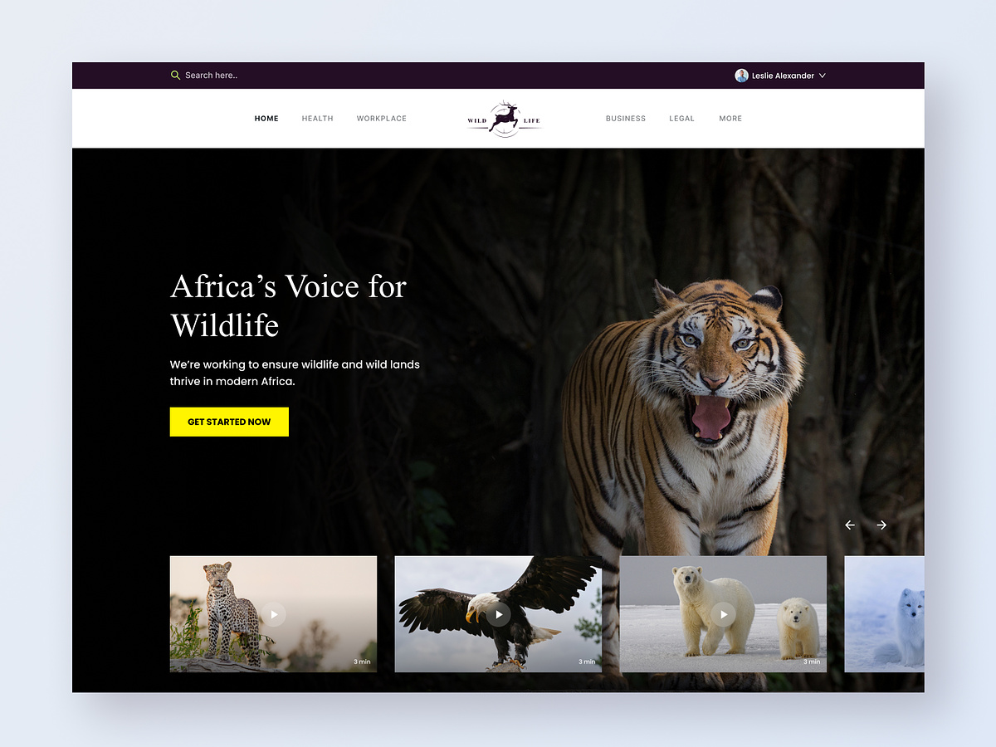

**___________________________________________________________________________**

**Outcomes:**

CO1: Comprehend process models

**__________________________________________________________________________**

**Conclusion: (Conclusion to be based on the outcomes achieved)**

We can conclude that we have started with the Mini Project on object oriented software engineering for a business application.

**Grade: AA / AB / BB / BC / CC / CD /DD**

**Signature of faculty in-charge with date**

**___________________________________________________________________________**

**References:**

**Books/ Journals/ Websites:**

1. Roger S. Pressman, Software Engineering: A practitioners Approach, 7th Edition, McGraw Hill, 2010
2. https://www.sharelatex.com/